**HandsOn 5**

1. Create new Dot net core project.

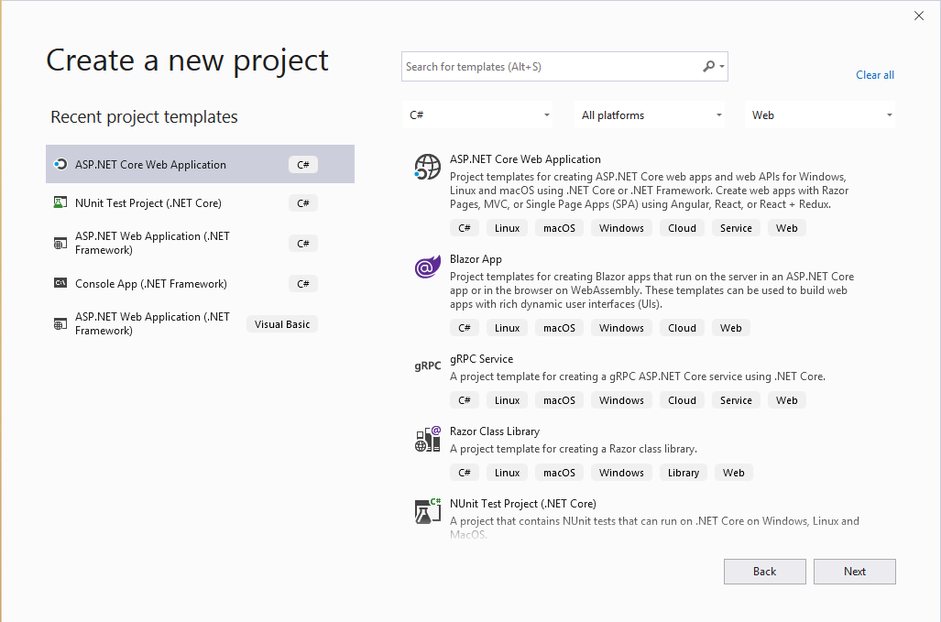

1. Enable the Docker support.

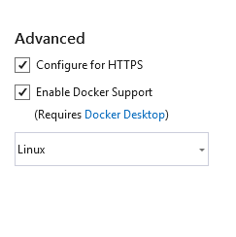

1. Select web api and create ta project.

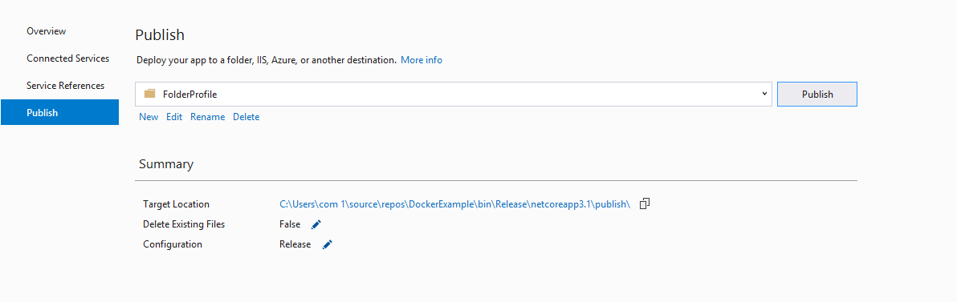

1. Right click on the solution and select publish. Select the target folder and click on publish.
2. Copy the publish folder under bin-> release and paste it under inetpub->wwwroot.

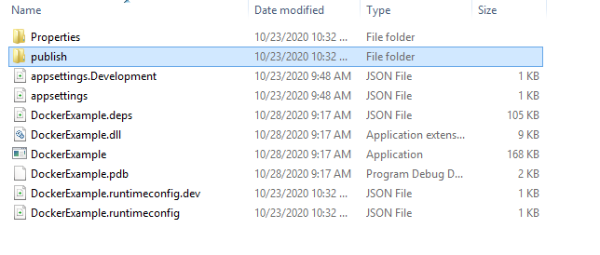



1. Start the iis and right click and select add website, select the site name and the physical path of the publish folder under wwwroot. Provide port number and add the website.

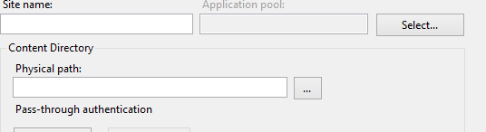

1. Use the port number in the web browser to explore the published site.

